SOFTWARE REQUIREMENT SPECIFICATIONS
(SRS)

Neural Style Transfer

KIET GROUP OF INSTITUTIONS
Department of Computer Science

Project Guide: Mr. Akash Goel
DATED: 15-04-2023
Submitted By: Palak Singh , Ragini Rani, Kalash Jain

Table of Contents
Table of Contents ii

1. Introduction 1
1.1 Purpose 1
1.2 Document Conventions 1
1.3 Intended Audience 2
1.4 Product Scope 2-3
1.5 References 3
1.6 Definitions 4
2. Overall Description 5
2.1 Product Perspective 5
2.2 Product Functions 6
2.3 User Classes and Characteristics 6-7
2.4 Operating Environment 7
2.5 Design and Implementation Constraints 7-9
2.6 User Documentation 9
2.7 Assumptions and Dependencies 9-10
3. External Interface Requirements 10
3.1 User Interfaces 10-11
3.2 Hardware Interfaces 11
3.3 Software Interfaces 11-12
3.4 Communications Interfaces 12
4. System Features 13
4.1 Functional Requirements 13-14
4.2 Use Cases 14
4.3 External Interface Requirements 15
4.4 Logical Database Requirements 15-16
4.5 Non-Functional Requirements 16

1. Introduction
Neural style transfer is a process that combines the content of one image with the style of the other by extracting the representation of two images using a pre-trained convolutional neural network. The algorithm uses optimization techniques to generate new images that provide the right content and features. This technique was introduced in a 2015 paper by Gatys et al. It is popular for its
applications in artistic rendering, video processing, virtual reality and image processing.

Purpose
Neural style transfer has the potential to be a game-changing technique for creating unique and visually stunning images, and for improving image recognition and interpretation in a variety of fields:
- Neural style transform can be used to create unique and stylized images by combining elements of one image with another.

- It can be used for photo and video editing, marketing and advertising, virtual reality and gaming, and medical imaging.

- Neural Style Transfer can help improve image recognition algorithms by providing a way to transfer patterns between images to accurately identify similar images.

- Provides powerful tools for creating beautiful and unique images that can improve visibility in many ways.

Document Conventions
- Use consistent terminology to describe key concepts and components of neural style transfer, such as content image, style image, feature representation, loss function, and optimization process.

- Include mathematical notation to describe algorithms and equations used in neural style transfer, including the mathematical formulation of the loss function and optimization process.

- Use diagrams and figures to illustrate key steps and components of neural style transfer, such as layers of the pre-trained convolutional neural network used to extract features, and the optimization process that generates the stylized output image.

- Provide code snippets or references to code repositories that implement neural style transfer algorithms to help readers better understand and implement the technique.

- Include examples and results of neural style transfer applied to different content and style images, to demonstrate the effectiveness and versatility of the technique.

- Provide references to relevant research papers, articles, and tutorials related to neural style transfer to help readers gain a deeper understanding of the technique and its applications.

Intended Audience
The intended audience for demonstrating neural style transfer is those who have a strong technical background in image processing, computer vision, and machine learning, and are interested in using neural style transfer for a variety of applications.

- The intended audience includes individuals with a background in image processing, computer vision, and machine learning.

- The audience should have a basic understanding of neural networks, convolutional neural networks, and image representation.

- They should also be familiar with optimization techniques and be able to understand mathematical notation and algorithms.

- The audience should be comfortable with programming and have experience working with Python and deep learning frameworks such as TensorFlow or PyTorch.

- The description should be written in a clear, concise, and informative style that is accessible to the intended audience.

- Diagrams, figures, code snippets, and examples should be included to help illustrate key concepts and components of neural style transfer.

- References to relevant research papers, articles, and tutorials should also be provided to help readers gain a deeper understanding of the technique and its applications.

Product Scope
The neural-style transfer product range covers features and requirements related to input processing, feature extraction, loss functions, optimization processes, user interface, performance, compatibility, and documentation. By meeting these requirements, the system can provide a high-quality, user-friendly platform for creating stylized output images using neural-style transfer techniques.

Purpose:
This system is designed to apply the style of one image to the content of another image using deep learning methods. The generated output must be of high quality and accurately reflect the style and content of the input image.

Functionality:
The system must be able to receive input images, including content and style images. It must also be able to process input images and produce stylized output. The system must be capable of 3D modeling based on the input image. The system should provide various output options such as image, video, and 3D model files.

Limitations:
The system has certain limitations, such as restrictions on the size of the input images that can be processed, significant processing time to generate output images, and significant computing resources required.

Target Users:
The system is intended for use by artists, designers, and other creative professionals who want to quickly and easily generate stylized images, videos, or 3D models.

Competitive Advantage:
The neural style transfer system has a competitive advantage over other image processing techniques, such as traditional image filters, due to its ability to generate high-quality stylized outputs that accurately reflect the style and content of the input images.

References
- Gatys,L.A., Ecker,A.S., & Bethge,M.( 2016). Image phraseology transfer utilizing convolutional neural networks. In suits of the congregation of IEEE on Computer Vision and Pattern Recognition(pp. 2414- 2423).

- Johnson,J., Alahi,A., & Fei- Fei,L.( 2016). Perceptual losses for real- time phraseology transfer andsuper-resolution. In European congregation on Computer unreality(pp. 694- 711).

- Huang,X., Belongie,S., & Adam,W.( 2017). Arbitrary phraseology transfer in real- time with adaptive case normalization. In Actions of the IEEE International Conference on Computer Vision(pp. 1501- 1510).

- Li,C., Wand,M., & Fei- Fei,L.( 2016). Combining Markov arbitrary fields and convolutional neural networks for image conflation. In Actions of the IEEE Conference on Computer Vision and Pattern Recognition(pp. 2479- 2486).

- Ulyanov,D., Lebedev,V., Vedaldi,A., & Lempitsky,V.( 2016). Texture networks Feed- forward conflation of textures and stylized images. In Actions of the International Conference on Machine Learning(pp. 1349- 1357).

- Chen,D., Yuan,L., Liao,J., Yu,N., & Hua,G.( 2017). Stylebank An unequivocal representation for neural image phraseology transfer. In Actions of the IEEE International Conference on Computer Vision(pp. 1824- 1832).

- Luan,F., Paris,S., Shechtman,E., & Bala,K.( 2017). Deep print phraseology transfer. In Actions of the IEEE Conference on Computer Vision and Pattern Recognition(pp. 4990- 4998).

- Li,X., Liu,S., Kautz,J., & Yang,M.H.( 2017). mastering direct metamorphoses for whirlwind arbitrary phraseology transfer. In Actions of the IEEE Conference on Computer Vision and Pattern Recognition(pp. 3911- 3920).

- Dumoulin,V., Shlens,J., & Kudlur,M.( 2016). A learned representation for cultural phraseology. In Actions of the International Conference on Learning Representations.

- Selim,A., Elgharib,M., & Doyle,L.( 2016). oil phraseology transfer for head pictures utilizing convolutional neural networks. In Conduct of the European Conference on Computer Vision Workshops(pp. 439- 453).

Definitions
- Neural style transfer: A technique that uses neural networks to apply the style of one image (e.g., a painting) to another image (e.g., a photograph) while preserving the content of the latter.

- Content image: The image that is used as the basis for the content of the final stylized image.

- Style image: The image that is used as the source of the style that will be applied to the content image.

- Stylized image: The final image that results from applying the style of the style image to the content of the content image.

- Feature map: A set of activations from a single filter that are generated by a convolutional neural network (CNN) layer for a specific input image.

- Gram matrix: A matrix that encodes the statistical correlations between the different feature maps in a CNN layer.

- Convolutional neural network (CNN): A type of artificial neural network commonly used in computer vision applications that uses convolutional layers to learn spatial features from input images.

- Transfer learning: A technique that allows a pre-trained CNN to be used as a starting point for a new task, such as neural style transfer.

- Backpropagation: A common algorithm used to train neural networks by computing the gradient of the loss function with respect to the network parameters and updating them accordingly.

- Optimization: The process of iteratively updating the parameters of the neural network to minimize the difference between the stylized image and the target image.

- Loss function: A function that measures the difference between the stylized image and the target image, which is used to guide the optimization process.

- Hyperparameters: Parameters of the neural network that are set before training and affect the performance of the model, such as the learning rate or the number of iterations.

- Content loss: The difference between the feature maps of the content image and the stylized image, which is used to preserve the content of the content image.

- Style loss: The difference between the Gram matrices of the style image and the stylized image, which is used to transfer the style of the style image to the stylized image.

- Total variation loss: A regularization term that encourages smoothness in the stylized image by penalizing high-frequency noise.

Acronyms and Abbreviations:

- CNN: Convolutional Neural Network

- GPU: Graphics Processing Unit

- API: Application Programming Interface

- VGG: Visual Geometry Group (a research group at the University of Oxford that developed a popular CNN architecture for computer vision tasks)

- SGD: Stochastic Gradient Descent (an optimization algorithm commonly used to train neural networks)

- FC: Fully Connected (a type of neural network layer where each neuron is connected to every neuron in the previous layer)

- ReLU: Rectified Linear Unit (a popular activation function for neural networks)

- BN: Batch Normalization (a technique used to normalize the activations of a neural network layer)

Overall Description

Product Perspective
Purpose: The purpose of the system is to allow users to generate stylized images by combining the content of one image with the style of another image, using neural network-based techniques.

Stakeholders:The stakeholders of the system include end-users, who are interested in generating stylized images for personal or professional use, as well as developers and researchers who are interested in exploring and advancing the state of the art in computer vision and deep learning.

Context: The system operates within a context of existing technologies and tools related to image processing, deep learning, and computer vision. The system should build upon and leverage existing frameworks and libraries, such as TensorFlow, PyTorch, and Keras, to provide a robust and efficient solution for neural style transfer.

Constraints: The system is subject to various constraints related to performance, scalability, and usability. The system should be designed and implemented in a way that optimizes for these constraints, while still providing a high-quality and user-friendly experience for users.

Opportunities: The system provides various opportunities for innovation and improvement, such as incorporating new neural network architectures, optimizing the optimization process, and integrating with other image processing tools and services.

Product Functions
The product functions of a neural style transfer system include the following:

Image loading: The system should allow users to upload or select input images (i.e., content and style images) from various sources, such as local files or online repositories.

Preprocessing: The system should preprocess the input images to extract features and prepare them for neural style transfer. This may involve resizing, normalization, and feature extraction using a pre-trained neural network.

Neural style transfer: The system should apply neural style transfer algorithms to combine the content and style of the input images and generate a stylized output image. This may involve iterative optimization techniques, such as gradient descent, to find the optimal image that matches the desired style.

Postprocessing: The system should postprocess the output image to enhance its quality and remove artifacts, such as noise or distortion. This may involve denoising, smoothing, or color adjustment techniques.

Output generation: The system should allow users to save or download the stylized output image in various formats, such as PNG, JPEG, or GIF, and share it on social media or other platforms.

User interface: The system should provide a user-friendly interface that allows users to interact with the system and customize various parameters, such as style strength, color preservation, and texture synthesis.

Overall, the product functions of a neural style transfer system involve image loading, preprocessing, neural style transfer, postprocessing, output generation, and user interface. By providing these functions, the system can enable users to generate high-quality stylized images with ease and flexibility.

User Classes and Characteristics
Novice users: These are users who are new to neural style transfer and may have limited knowledge of deep learning or computer vision. They may be interested in using the system for personal use, such as generating stylized images for social media or artistic purposes.

Intermediate users: These are users who have some experience with neural style transfer and may have a basic understanding of deep learning or computer vision. They may be interested in using the system for professional or commercial use, such as generating stylized images for marketing or branding purposes.

Expert users: These are users who have advanced knowledge and expertise in neural style transfer and may be researchers or developers in the field of deep learning or computer vision. They may be interested in using the system for experimental or innovative purposes, such as exploring new neural network architectures or optimization techniques.

Characteristics: The characteristics of users of a neural style transfer system may vary depending on their level of experience and expertise. Novice users may prioritize ease of use and simplicity, while intermediate and expert users may prioritize flexibility and customization. All users may value the quality and realism of the stylized output images, as well as the speed and efficiency of the system.

Operating Environment
Hardware requirements: The system should be able to run on a variety of hardware platforms, such as desktop computers, laptops, or mobile devices. The hardware requirements may vary depending on the complexity of the neural network architecture and the size of the input images.

Software requirements: The system should be compatible with various software libraries and frameworks, such as TensorFlow, PyTorch, or Keras. The software requirements may depend on the specific neural network architecture and optimization techniques used by the system.

Operating system: The system should be able to run on different operating systems, such as Windows, macOS, or Linux. The operating system requirements may depend on the software libraries and frameworks used by the system, as well as the hardware specifications of the user's device.

Internet connection: The system may require an internet connection to access online repositories of pre-trained neural network models or to upload or download input and output images.

User interface: The system should provide a user-friendly interface that can run on various platforms and devices, such as web browsers or mobile apps. The user interface should be designed to optimize the user experience and allow users to interact with the system efficiently.

Design and Implementation Constraints

Design and implementation are critical aspects of developing a neural style transfer system. The system should be designed and implemented with the following considerations:

Architecture selection: The system should use a suitable neural network architecture for style transfer, such as VGG, Inception, or ResNet. The choice of architecture will affect the quality and speed of stylized output images

ER Diagram
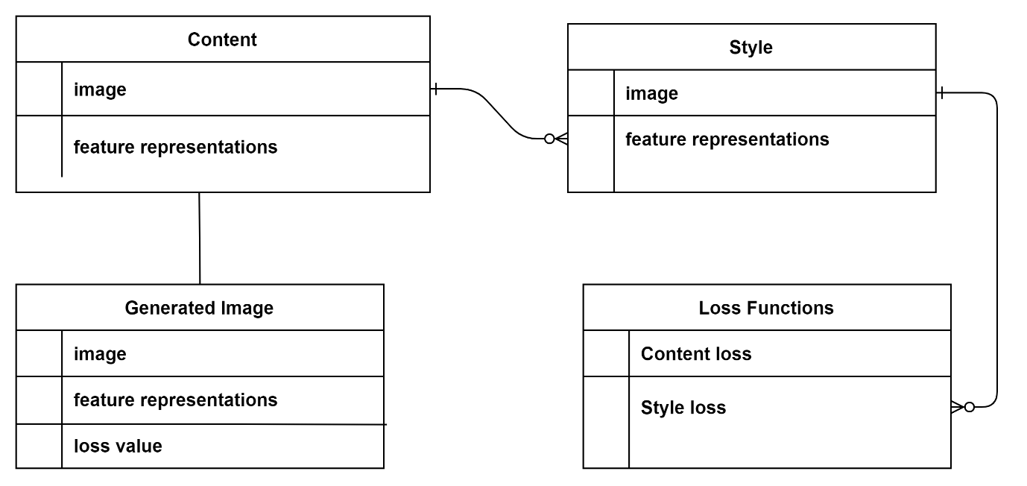

Pre-processing and post-processing: The system should include pre-processing and post-processing steps to optimize the input and output images. For example, pre-processing may involve resizing or cropping the input images, while post-processing may involve adjusting the brightness or contrast of the output images.

Loss function: The system should define a loss function that balances the content and style of the input and output images. The loss function should be designed to optimize the style transfer process and produce high-quality stylized output images.

Optimization algorithm: The system should use an efficient optimization algorithm, such as gradient descent or Adam, to minimize the loss function and generate stylized output images.

Hyperparameter tuning: The system should include a mechanism for hyperparameter tuning, such as grid search or random search, to optimize the performance of the system.

Code implementation: The system should be implemented in a suitable programming language, such as Python or MATLAB, using relevant software libraries and frameworks, such as TensorFlow or PyTorch. The code should be well-organized and documented to facilitate maintenance and future development.

User Documentation
User documentation is an essential component of a neural style transfer system, as it provides users with the information they need to use the system effectively. The user documentation should include the following:

Overview: The documentation should provide an overview of the system and its capabilities. This section should include a brief introduction to neural style transfer and an explanation of how the system works.

Getting started: The documentation should include a section on getting started with the system. This section should cover installation and setup instructions, system requirements, and any other necessary steps to prepare the system for use.

User interface: The documentation should provide an overview of the system's user interface and how to use it. This section should cover how to select input and style images, adjust parameters, and preview stylized output images.

Input and output formats: The documentation should explain the supported input and output image formats, including the file extensions, color spaces, and other relevant information.

Style transfer modes: The documentation should explain the different modes of style transfer available in the system, including single-style transfer, multi-style transfer, and video style transfer.

Troubleshooting: The documentation should include a section on troubleshooting common issues that users may encounter when using the system. This section should provide step-by-step instructions for resolving these issues.

FAQs: The documentation should include a section on frequently asked questions (FAQs) to help users find quick answers to common questions.

Glossary: The documentation should include a glossary of terms used in the system to help users understand technical jargon and concepts.

Assumptions and Dependencies
Assumptions:

- Availability of hardware resources: The system assumes that the user has access to sufficient hardware resources, such as CPU, GPU, or TPU, to run the system efficiently. The system's performance is directly related to the hardware resources available, so users with limited resources may experience slower performance or reduced output quality.

- Adequate training data: The system assumes that sufficient training data is available to train the style transfer models effectively. Without adequate training data, the system may produce low-quality stylized output images or fail to work altogether.

- Familiarity with neural style transfer: The system assumes that users have some basic knowledge of neural style transfer and its underlying principles. Users who are unfamiliar with neural style transfer may require additional training or support to use the system effectively.

Dependencies:

- Software dependencies: The system may have dependencies on third-party software libraries, frameworks, or APIs, such as TensorFlow or PyTorch. These dependencies must be installed and configured correctly for the system to work properly.

- Input and output image formats: The system depends on various input and output image formats, such as JPEG, PNG, or BMP. Users must provide input images in one of the supported formats, and the system will output stylized images in the same format.

- Training data: The system depends on a diverse set of training data to produce high-quality stylized output images. Developers must ensure that the training data is up-to-date and relevant to the intended use cases.

- Hardware dependencies: The system may have dependencies on specific hardware, such as GPUs or TPUs, to achieve optimal performance. Users must have access to the necessary hardware resources to use the system effectively.

External Interface Requirements

User Interfaces
Web Interface: A web interface is a common user interface for neural style transfer systems. Users can access the system through a web browser, upload their images, choose a style, adjust parameters, and preview the stylized output image.

Mobile Application: A mobile application is another popular user interface for neural style transfer systems. Users can access the system through their smartphones or tablets, select and upload images, choose a style, adjust parameters, and preview the stylized output image.

Command-Line Interface: Some neural style transfer systems may also provide a command-line interface for advanced users. Users can access the system through a terminal, specify input and output files, choose a style, adjust parameters, and generate the stylized output image.

Graphical User Interface: A graphical user interface (GUI) is a user interface that allows users to interact with the system using graphical elements such as buttons, sliders, and menus. GUIs are commonly used in desktop applications and can provide a rich user experience.

Plugin for Image Editing Software: Some neural style transfer systems may also provide a plugin for popular image editing software such as Photoshop or GIMP. The plugin allows users to apply stylized filters directly to their images without leaving the image editing software.

Hardware Interfaces
A neural style transfer system can be hardware-intensive and may require specific hardware interfaces to achieve optimal performance. The following are the common hardware interfaces that a neural style transfer system may require:

Graphics Processing Unit (GPU): A GPU is a specialized hardware component designed to handle parallel computations that involve large amounts of data. Neural style transfer algorithms require a significant amount of computation, and a GPU can speed up the processing time by executing multiple operations in parallel. The system should be compatible with a GPU and have the necessary software drivers and libraries installed to use the GPU effectively.

Central Processing Unit (CPU): A CPU is the primary processor of a computer or device and can be used to run neural style transfer algorithms. However, the processing time may be slower compared to using a GPU. The system should be compatible with the CPU architecture and have the necessary software libraries installed to use the CPU effectively.

Memory: Neural style transfer algorithms require a large amount of memory to store and process image data. The system's memory should have sufficient capacity to store input and output images and any intermediate data generated by the algorithm. The memory should be fast and have low latency to minimize processing time.

Storage: The system's storage should have sufficient capacity to store input and output images and any intermediate data generated by the algorithm. The storage should be fast, reliable, and have low latency to minimize processing time.

Network Interface: Neural style transfer algorithms may require network connectivity to download models, datasets, or other resources required for the algorithm. The system should have a network interface to access these resources.

Software Interfaces
A neural style transfer system requires different software interfaces to interact with other software components and perform the required tasks. The following are some common software interfaces for neural style transfer systems:

Application Programming Interface (API): An API is a set of protocols and tools for building software applications. A neural style transfer system may provide an API for developers to integrate the system into their applications or services. The API should be well-documented, easy to use, and provide clear instructions for developers to use the system.

Programming Languages: Neural style transfer systems may require the use of specific programming languages to implement the algorithm or to build custom applications. Common programming languages for neural style transfer include Python, C++, and MATLAB. The system should be compatible with different programming languages and provide the necessary libraries and tools for developers to build custom applications.

Data Formats: Neural style transfer systems may require specific data formats for input and output images. Common data formats for neural style transfer include JPEG, PNG, and TIFF. The system should be compatible with different data formats and provide the necessary tools to convert images to the required format.

Operating Systems: Neural style transfer systems may run on different operating systems, such as Windows, macOS, and Linux. The system should be compatible with different operating systems and provide the necessary software drivers and libraries to use the system effectively.

Web Interfaces: Neural style transfer systems may provide a web interface for users to interact with the system through a web browser. The web interface should be easy to use, responsive, and provide clear instructions for users to upload images and adjust the style transfer parameters.

Communications Interfaces
Communication interfaces refer to the protocols and methods used for communication between different software components or systems. In a neural style transfer system, communication interfaces are essential for integrating different components and ensuring that they work together seamlessly. Some common communication interfaces for neural style transfer systems include:

HTTP/HTTPS: Hypertext Transfer Protocol (HTTP) and its secure version (HTTPS) are widely used for communication between web applications and servers. Neural style transfer systems may use HTTP/HTTPS to communicate between the web interface and the server.

REST: Representational State Transfer (REST) is a set of architectural constraints and principles used for designing web services. RESTful APIs provide a standardized way of communicating between different software components and systems.

TCP/IP: Transmission Control Protocol/Internet Protocol (TCP/IP) is a suite of communication protocols used for connecting devices to the internet. Neural style transfer systems may use TCP/IP to communicate between different devices or components in the system.

WebSocket: WebSocket is a protocol for real-time communication between web applications and servers. Neural style transfer systems may use WebSocket to provide real-time feedback to users during the style transfer process.

MQTT: Message Queuing Telemetry Transport (MQTT) is a lightweight protocol used for machine-to-machine communication. Neural style transfer systems may use MQTT to communicate between different devices or components in the system.

The choice of communication interface depends on the specific requirements of the neural style transfer system and the software components being used. It is essential to design communication interfaces that are reliable, efficient, and easy to use to ensure that the system operates smoothly.

System Features
System features are the functions and capabilities that a neural style transfer system provides to its users. The specific features of a neural style transfer system may vary depending on the requirements of the system and the needs of the users. It is essential to design a system that provides the necessary features while also being easy to use and efficient.

4.1 Functional Requirements:

Functional requirements are the specific actions and tasks that a neural style transfer system must perform to meet the needs of its users. Some common functional requirements of neural style transfer systems include:

Image upload: Users should be able to upload an image to be processed for style transfer.

Style selection: Users should be able to select a style from a library of pre-defined styles or upload their own style image.

Parameter adjustment: Users should be able to adjust the style transfer parameters such as the style strength, content weight, and learning rate.

Preview: Users should be able to preview the style transfer results in real-time before applying the changes.

Style transfer: The system should perform the style transfer process accurately and efficiently, preserving the content of the input image while applying the selected style.

Image filtering: Users should be able to apply various image filters to the input and output images.

Batch processing: Users should be able to apply the same style to multiple images in a batch process.

Image processing: Users should be able to perform basic image processing tasks such as cropping and resizing within the neural style transfer system.

User management: The system should provide user management features such as user authentication, access control, and user profile management.

Integration: The system should be able to integrate with other systems and platforms, such as content management systems, e-commerce platforms, and social media platforms.

Error handling: The system should be able to handle errors and exceptions that may occur during the style transfer process and provide informative error messages to users.

The specific functional requirements of a neural style transfer system may vary depending on the needs of the users and the requirements of the system. It is important to define and prioritize the functional requirements to ensure that the system meets the needs of its users.

4.2 Use Cases

4.2 Use Cases:

Use cases are descriptions of how a user interacts with a system to achieve a specific goal. In the context of a neural style transfer system, some example use cases may include:

Apply style to an image: The user uploads an image and selects a style from a library of pre-defined styles or uploads their own style image. They adjust the style transfer parameters to their liking and preview the results before applying the changes.

Batch process multiple images: The user selects a set of images and applies the same style to each image in a batch process. They can preview the results and download the processed images.

Crop and resize images: The user can perform basic image processing tasks such as cropping and resizing within the neural style transfer system before applying the style transfer process.

Apply filters to images: The user can apply various image filters to the input and output images to enhance the visual quality.

Integrate with other systems: The user can integrate the neural style transfer system with other systems and platforms, such as content management systems, e-commerce platforms, and social media platforms, to enhance the user experience.
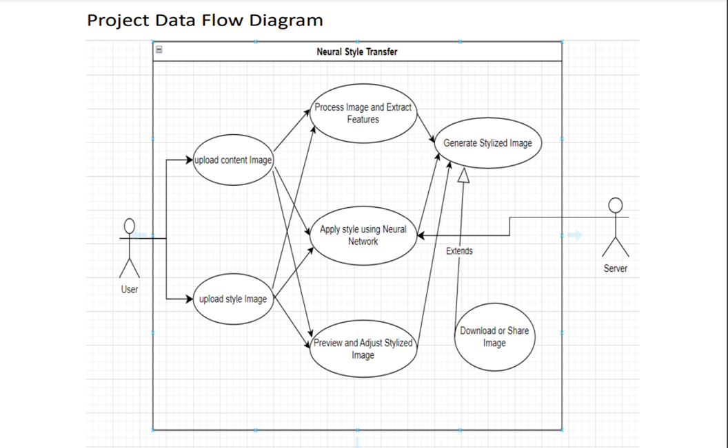

Manage user profile: The user can manage their profile and preferences within the neural style transfer system, such as updating their personal information, viewing their processing history, and setting notification preferences.

Apply style to video: The user uploads a video and applies the selected style to each frame of the video. They can preview the results and download the processed video.

Each use case represents a specific scenario in which a user interacts with the neural style transfer system to achieve a goal. It is important to identify and prioritize the use cases to ensure that the system meets the needs of its users.

4.3 External Interface Requirements:

User interface: The system must provide a user-friendly interface that allows users to upload images or videos, select styles, adjust parameters, preview results, and download processed content.

API: The system must expose an API that allows other systems to interact with it programmatically. The API should allow users to upload images, select styles, and retrieve processed images or videos.

File formats: The system must support various image and video file formats, such as JPEG, PNG, MP4, and MOV. It should also support common style image formats, such as JPEG and PNG.

Performance: The system must be able to process images and videos within a reasonable amount of time. It should also be able to handle multiple requests simultaneously without experiencing significant performance degradation.

Security: The system must implement appropriate security measures to protect user data and prevent unauthorized access. This may include encryption, authentication, and access control mechanisms.

Integration: The system should be able to integrate with other systems and platforms, such as content management systems, e-commerce platforms, and social media platforms. It should also support standard protocols and interfaces, such as REST, SOAP, and OAuth.

Hardware requirements: The system should specify the hardware requirements for running the neural style transfer algorithm, such as the amount of RAM, CPU, and GPU required. It should also specify the compatibility of the system with specific hardware devices, such as graphics cards or cameras.

By identifying and specifying the external interface requirements, the system can ensure that it interacts effectively with external entities and meets the needs of its users.

4.4 Logical Database Requirements:

User interface: The system must provide a user-friendly interface that allows users to upload images or videos, select styles, adjust parameters, preview results, and download processed content.

API: The system must expose an API that allows other systems to interact with it programmatically. The API should allow users to upload images, select styles, and retrieve processed images or videos.

File formats: The system must support various image and video file formats, such as JPEG, PNG, MP4, and MOV. It should also support common style image formats, such as JPEG and PNG.

Performance: The system must be able to process images and videos within a reasonable amount of time. It should also be able to handle multiple requests simultaneously without experiencing significant performance degradation.

Security: The system must implement appropriate security measures to protect user data and prevent unauthorized access. This may include encryption, authentication, and access control mechanisms.

Integration: The system should be able to integrate with other systems and platforms, such as content management systems, e-commerce platforms, and social media platforms. It should also support standard protocols and interfaces, such as REST, SOAP, and OAuth.

Hardware requirements: The system should specify the hardware requirements for running the neural style transfer algorithm, such as the amount of RAM, CPU, and GPU required. It should also specify the compatibility of the system with specific hardware devices, such as graphics cards or cameras.

By identifying and specifying the external interface requirements, the system can ensure that it interacts effectively with external entities and meets the needs of its users.

4.5 Non-functional Requirements:

Non-functional requirements are the system requirements that specify how the system should perform, rather than what it should do. They describe the overall characteristics of the system and the constraints within which it operates. Some examples of non-functional requirements for a neural style transfer system might include:

Performance: The system should be able to process images and videos quickly and efficiently. This may include requirements for processing time, response time, and throughput.

Trustability: The network should be dependable and accessible at all moments. This may include requirements for uptime, error handling, and fault tolerance.

Security: The system should be secure and protect user data from unauthorized access or modification. This may include requirements for authentication, authorization, encryption, and data privacy.

Usability: The system should be easy to use and navigate. This may include requirements for user interface design, user experience, and accessibility.

Scalability: The system should be suitable to manage an adding number of druggies and queries. This may include requirements for load balancing, clustering, and resource allocation.

Compatibility: The system should be compatible with a wide range of platforms, devices, and file formats. This may include requirements for interoperability, integration, and version control.

By specifying non-functional requirements, the system can ensure that it meets the expectations of its users and operates effectively within its environment.

